To: Dr. David Willy; Husain Sodawalla
From: Northrop Grumman Capstone Team
Date: 1-19-24
Re: Project Management Memo

Introduction
Having completed the first semester’s worth of work, the Northrop Grumman Drill Arm team has compiled a list of both reflections on the initial effort and a plan as to how future efforts should be conducted based on lessons learned in the first semester. This memo will serve as the team’s first assignment together for the semester, setting the project up for success in the second semester of effort by outlining what work has been done, what work is left to be done, what has been learned from this past semester, and how the team should go about completing the final semester’s worth of work. These plans will be laid out in the form of a reflection on the last semester, the successes seen by the team, the areas which could be improved upon, tasks which still need to be accomplished, remaining design efforts, a rough Gantt chart of what the tasks will be coming into next semester, a purchasing plan, and a manufacturing plan.
Reflection
Overall, the previous semester was successful but there were times that could have been better for the team. Since the team found that they worked well together, which will be going forward into next semester. Everyone on the team had their roles and if someone needed help there was always another teammate that would. All reports and presentations went well throughout the semester, giving the audience a strong idea of what the team was doing and trying to accomplish. One thing the team struggled with was the first prototype, in which there were problems with the electronics and code which made the robot not move. The team took that as a learning point to then create an extraordinarily successful second prototype. Based on the first semester, the team needs to work on meeting up as a group more often to work on the large deliverables more than a week ahead of the due date.
Successes
Throughout the previous semester the Northrop Grumman team found its most success in presentation and prototyping. One of the team's most important presentations was to the team's sponsor, Northrop Grumman. This presentation was a preliminary design report which covered everything the team had done. Which included benching marking, calculations, budgeting, system models, and concept selection. The employees of Northrop Grumman were impressed with what the team had done at that point. Another major accomplishment the team had was prototype two, which learned a lot from prototype one. The team accomplished a robotic arm that could move with two degrees of freedom. That movement was controlled by a code that corresponded to keyboard buttons that moved the robot up, down, out, and in. This prototype was a huge step in the right direction for the team now being able to control the robot. Below is a list of these previously stated successes.
- Presentations including PDR and in-class presentations.
- Prototype two, having a working and moving prototype two.
- Having very cohesive and compiled data and information to show how and why we chose the design as well as how it will work come design day.
Room for Improvements
Within this list there are a few things that the team can improve on going into the next semester, these improvements can help with the team's overall success. Although the team has done a satisfactory job in designing the robotic drilling arm thus far, there is always room for improvement.
- More communication between all members of the team
- Having all members be at team meetings more often
- Be more prepared for assignments that take longer than expected.
- The entire team needs to work on coding skills.
- Apply more pressure to companies that could donate to the team.
Action Items
- Receive donations toward 10% fundraising goal.
  - This will help the team buy more products going toward the final design.
  - Aid in last minute purchases if given that purchasing through NAU takes time.
- Team members need to be machine shop certified.
  - To ensure different members in the design are made in a timely manner and not having to wait for someone else to make the parts.
- Start ordering parts that will be within the final design.
  - This will ensure that the team has all parts without feeling pressure of time toward the end of the semester.
- Reach out to NAU to make sure the Northrop Grumman budget is being used.
  - This will take time and if the team does not do this soon, there will be no time to complete this project.
- Tell Northrop Grumman that the team needs to have more constructive criticism.
  - Although Northrop Grumman has assisted the team more constructive criticism will help the team to be successful instead of hearing that all information thus far is great.
- Document the overall design and building process.
  - The team needs to be taking more videos and pictures of the design process to show Northrop Grumman as well as have pictures for the website gallery.
- Finalize all design criteria to ensure the team is on the same page.
  - Finalizing all essential information within the design will help the team move forward and allow for the team to have a cohesive and well-made design.
- Be more communicative with Northrop Grumman clients.
  - The team meets with Northrop Grumman biweekly, although the information the clients say they will provide is often not followed through. Even though the team will not depend on this information it would be nice to have it going further.
- Be prepared for the CDR presentation to Northrop Grumman
  - Being more prepared for this presentation will help the team have more success going forward as well as potentially coincide with a capstone assignment that can be switched out with the presentations.
- Prepare for Northrop Grumman Design Day
  - Being prepared for the design day hosted by Northrop Grumman will allow the team to ensure the device being built will be at the competition and fully functional.
- Preparation for UGRAD registration and presentation
  - Many deadlines are associated with UGRAD’s, the team will need to be very prepared as this is 20% of the final grade.
Remaining Design Efforts
- Order all parts including hardware, motors, aluminum for entire robot and document all purchase orders accounting for money spent and remaining.
- Have all members of the team scheduled for machine shop training to avoid wait time in manufacturing parts.
- Ensure that the slewing drive as well as spindle are purchased as soon as possible given the entire building process relies heavily on those parts.
- Begin deciding our testing methods for our design and what we need to complete these tests with precision and accuracy.
Gantt Chart
As seen in Table 1 below, there are many tasks to be completed by the team from Week 1 to the first Hardware Update. Each is critical to the project's success throughout the rest of the semester, as each task builds upon the project in some fundamental way, shape, or form.

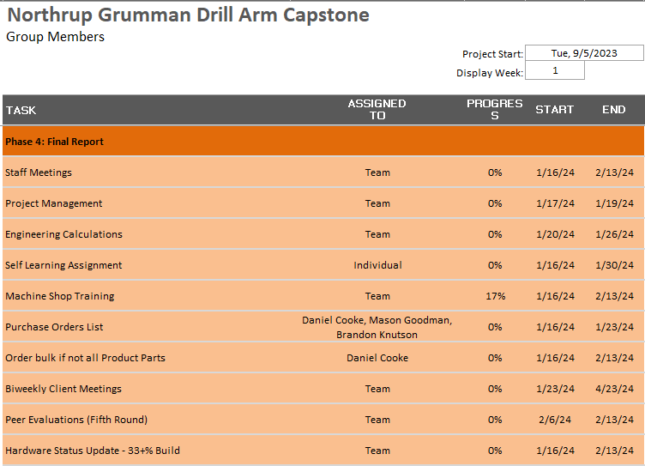
Table 1: Gantt Chart for Second Semester
- Hardware Status Update – 33% Build: At this point in time, the 33% build status goal for the team will consist of ordering all parts possible and having the main components of the product’s base manufactured. All members of the team will contribute to manufacturing, and it is Daniel Cooke’s job to ensure that all products on the purchase orders list are ordered. This will begin on January 20th and run until the 33% build status update on February 13th, 2024.
- Peer Evaluations: A peer evaluation will be conducted at the end of this period of work to give the team an opportunity to provide one another with feedback, alongside giving feedback to other teams. These will open on February 6th and must be completed by midnight on February 13th.
- Biweekly Client Meetings: Client meetings will now take place biweekly starting on Tuesday January 23rd. These are in place to communicate with the client about where the project is at, what needs to be done, and any issues which need resolving. These will run biweekly until the product is completed and handed off to the client in April.
- Order the bulk of if not all Product Parts: As the team’s Financial Manager, Daniel Cooke will be responsible for ordering each of the product parts for the team. On January 18th, 2024, the team went over the purchasing orders list together and determined the first initial necessary parts which must be ordered. Ideally, no further items will be added after Daniel buys these items from January 19th through the 22nd. Because the client has already supplied NAU’s Mechanical Engineering Department with the funds to purchase parts, Daniel can begin ordering immediately.
- Purchase Orders List: This list will contain all necessary purchases made by the team. Each purchase made towards the final product will be tracked and confirmed upon delivery to keep a running inventory of what has and has not been purchased and delivered. This list will be maintained by Daniel Cooke (the team’s Financial Manager), Mason Goodman (Manufacturing Engineer), and Brandon Knutson (Test Engineer). This has already been started by the team and will continue until the project’s end, with additions being made as is necessary.
- Machine Shop Training: Members of the NG Drill Arm Team plan to receive Machine Shop training and certification to drive down manufacturing costs. At the time of writing, Northern Arizona University’s Machine Shop has yet to post their training times on their website, so the team cannot sign up now but will do so as soon as possible.
- Self-Learning Assignment: A secondary self-learning assignment like those undertaken in the first semester will be given to the team to complete in each member’s own time. These will further the overall project in some way, shape, or form, through calculations and analysis. For the purposes of the team’s efforts this semester, each member of the team has agreed to receive basic safety training for Northern Arizona University’s Machine Shop (except for Brandon Knutson, who already has completed his training) such that all team members can contribute to manufacturing product parts. The training is necessary to help reduce manufacturing costs and save funds for more necessary expenditures such as product parts and travel costs. Ideally, the sooner this training is completed, the better, so once the training times are posted, the team will sign up and receive training for the earliest possible times to complete it as soon as possible. Because only one session is needed for the certification to handle basic machine shop equipment, the need to attend more than one session is not necessary unless advanced safety training is desired by a team member.
- Engineering Calculations: The Engineering Calculations memo is focused around combining all calculations performed by the team into a single continuous memo. This includes all fundamental calculations, any additional or exploratory calculations, and any calculations determining the safety or functionality of parts, along with a complete set of tables and equations. This will be completed by the team before the due date of January 26th, 2024, and will be started as soon as the Project Management memo is completed.
- Project Management: This Project Management memo will be referenced by the team during the beginning week of the semester to ascertain whether any changes need to be made and to give everyone a refresher on the plan. At the time of writing, changes are being made to the original Project Management memo from last semester. The more notable changes are to the Gantt chart (to include more detailed entries on upcoming tasks as well as more tasks which have since been added), the purchasing plan (to include specific items to be purchased shortly), the team’s Bill of Materials, and an updated manufacturing plan (to include what parts of the final product will be manufactured by various members of the team and which will be placed as NAU’s Machine Shop orders).
- Staff meetings, as always, will be in place for the team to come together and give important updates, make plans, and adjust tasks if necessary. Something not shown but that could ideally be accomplished during this period would be to get most if not all the team certified for machine shop tool usage. These meetings will begin taking place as soon as the semester begins (1/16/24) and will end the week before the semester ends (4/30/24). All team members will participate.

Purchasing Plan
There are several components that have been selected for the final product that will take significant planning prior to their purchase. The most expensive item is the slewing drive. This essential part of the robot is priced at 2000 dollars and has a lead time of about four weeks. The team is currently in contact with a slewing drive manufacturer called SlewPro to possibly receive a discount on the drive to apply towards the team’s fundraising goal. The next component that the team will need to purchase is the spindle. The spindle the team has selected costs about 100 dollars and will take two weeks from arrival. The purchase orders for the spindle and slewing drive are being completed and will be filed with Northrop Grumman and the NAU engineering department before the end of the first week of the semester. The Nema 34 stepper motors and the gear boxes needed for the design cost 490 dollars and a lead time of two weeks. As of now, this is the planned course of action for controlling the robotic arms' movement, but it will not be confirmed until the most accurate power requirements are calculated. The final decision and purchase order for these components will occur in the first week of the next semester.
It is not expected that the major controlling devices such as motors and the spindle will arrive in time the first hardware check. The team’s goal is to have all raw materials for the manufacture of the main members of the robotic arm. The materials required for the preliminary hardware check include the aluminum sheets and square tubes, as well as the hardware to hold everything together. This is to give the team the longest amount of time to work with the machine shop in the manufacturing process of the robot. The second hardware check will include the motors, gear boxes, and all the electronic components to ensure enough time to include the project's automated aspect. The spindle, slewing drive, and anything required to mobilize the robot will not be included until the final hardware check. Yet, the team is still planning to file the purchase orders for the entire bill of materials within the first three weeks of the semester, based on lead time and part importance.
All electronic components, motor drivers, and magnetic encoders will also be purchased in the first week of the next semester. Most of the electronics will be purchased from Amazon, and have a short lead time, but due to their lack of durability, it is necessary to acquire these items as soon as possible. As the team is still considering options for the pulley system that will actuate the movement of the arms from the motors, more research needs to be done prior to the purchasing of these items. These calculations will be completed by week two of the next semester, with selection and purchase of these items occurring no later than week three. All other necessary components including bearings, hardware, and excess electronic items will be purchased “as needed”. The required parts that have a lead time of more than one week will be purchased no later than week four of the next semester. Table 2 below shows the order in which the parts will be ordered. The complete bill of materials can be found in Appendix A.

Week | Part to Purchase | Lead Time (Weeks)
1 (by 1/19) | - Slewing Drive  - Spindle  - Raw Aluminum  - Motors  - Gear Boxes  - Electronic Components | - 4  - 2  - 2  - 2  - 2  - 1
2 (by 1/26) | - Bearings  - Power Supply  - VFD | - 2  - 1  - 1
3 (by 2/2) | - Gear and Pulley System  - Belts | - 1  - 1
4 (by 2/9) | - Hardware As Needed  - Cabinet Dolly  - Floor Securing Mechanism | - 1  - 1  - 1
5 (by 2/16) | - Emergency Purchases | - TBD
Table 2: Purchasing Plan

Manufacturing Plan
For the manufacturing phase of the system, the team acknowledges certain oversights in the design and recognizes the need for revisions, particularly in the belt power transmission system and the main shaft for the lower shank and power output. The team aims to complete these redesigns within two weeks. Concurrently, while these design aspects are being addressed, it is imperative to commence the manufacturing of linkages, triplates, and shanks at the earliest possible time. To expedite this process, the team will engage with various manufacturing companies both locally in Flagstaff and across the broader Arizona area. The intention is to leverage external expertise for shaping the external profiles, while the team will handle hole positions due to their critical tolerance requirements.
Regarding the shaft and power transmission components, the specific design approach will hinge on the final decision but will lean towards simplicity to enable execution by team members without reliance on machine shop managers or external manufacturers. However, the base of the design presents a higher level of complexity, necessitating the involvement of a machine shop manager. Consequently, swift finalization of the design is crucial to accommodate the expected lead time. Additionally, for the base, the team plans to place an order for the slewing drive within the first week of the semester, considering its lengthier lead time. Welding may also be a requisite skill, and one or more team members are set to embark on a self-learning assignment for machine shop training at the outset of the semester.
Conclusion
Throughout the previous semester, the team was able to complete various tasks that aided in the success of the robotic drilling arm that is being built. There were many components that weighed heavily in this success such as presentations and prototyping which in time proved that the design the team chose was accurate and will perform well during competition. The team is aware of some areas of improvement going forward, such as the commitment level and involvement in the project. As observed by Professor Willy, the team has not been working as a cohesive unit. The individual research completed by the team members has not come together to make genuine progress. However, the team will continue to strive for unity in the work being completed. With an in-depth purchasing plan created the team will be ordering within the first two weeks of the semester and will be on track for all hardware checks going forward within this semester. Manufacturing plans have been revised and will be worked on going further once building begins. The most important part of this manufacturing plan is getting all members of the team trained at the machine shop to eliminate wait times during the building process. With the newly updated Gantt chart, the team can quickly get going at the start of the current semester and waste little time trying to remember what exactly needs to be done. The manufacturing and purchasing plans will also aid in this fashion, as they too will provide the team with a solid plan as to what needs to be done next. With all of this in mind and put together in one memo, the team can begin this semester with confidence to complete the work begun on Northrop Grumman’s drill arm this semester.

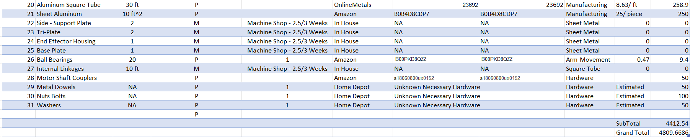
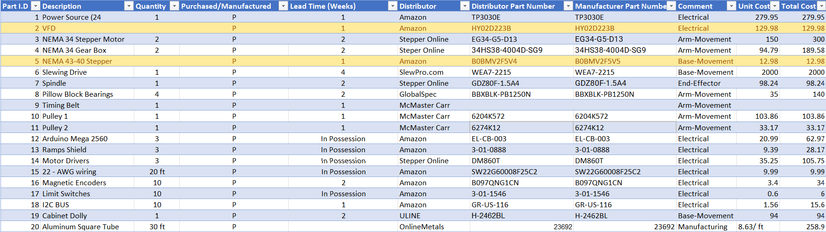
Appendix A- Bill of Materials

